# Local Email Service Configuration

Contents

Local Email Service Configuration 1

Revision History 2

Presupposition 3

Introduction 3

AUI Setting 4

AUI related code location: 5

## Revision History

|  |  |  |  |
| --- | --- | --- | --- |
| **Date** | **Version** | **Author** | **Description** |
| Aug 22, 2015 | 1 | Chandler Xue | Initial |

## Presupposition

**Important: Run the SQL script below at the target DB before set up local email service**



## Introduction

This document is a short introduction about email service configuration, team rookie can use it as a reference to learn how to setup and debug email related issue. And please feel free to connect me if there is any misunderstanding.

.

## AUI Setting

**Location:** Administration Home » System Settings » Configuration - Internet Staff

Fill configuration information as below and save.

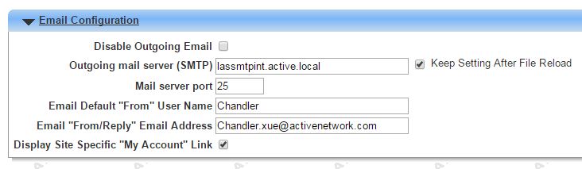

**Jar Setting:** Copy mail.jar from “\Third Party Stuff\Files” to “\ActiveNetServlet\build\web\WEB-INF\lib” if no existing.

**Tomcat Setting:** Add “-Djava.net.preferIPv4Stack=true” in “\tomcat\bin\catalina.bat” as below.

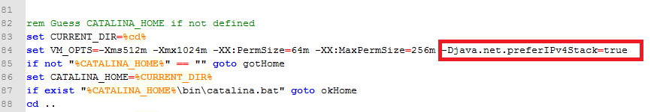

## AUI related code location:

**Class:**

ActiveNetLib.Tools.Email

**Function:**

Add a breakpoint at below function, all the email will send though this function, you can check whether the email send out successfully.

ActiveNetLib.Tools.Email.send()